**SAVEETHA SCHOOL OF ENGINEERING**

**SAVEETHA INSTITUTE OF MEDICAL AND TECHNICAL SCIENCES**

**ITA 0451 - STATISTICS WITH R PROGRAMMING**

**DAY 4 – LAB ASSESSMENT Part 4**

Reg No: 192124133

Name: Bala Manohar. J

1. a. Create multi regression model to find a weight of the chicken , by “Time” and

“Diet” as as

predictor variables

b. Predict weight for Time=10 and Diet=1

c. Find the error in model for same

SOURCE CODE:

a)

time <- c(1, 2, 3, 4, 5, 6, 7, 8, 9, 10)

diet <- c(1, 2, 1, 2, 1, 2, 1, 2, 1, 2)

weight <- c(1.2, 1.8, 1.4, 2.1, 1.6, 2.2, 1.9, 2.4, 2.0, 2.6)

model <- lm(weight ~ time + diet)

summary(model)

b)

new_data <- data.frame(time = 10, diet = 1)

predict(model, newdata = new_data)

c)

install.packages("caret")

library(caret)

rmse <- sqrt(mean((model$fitted.values - weight)^2))

rmse

OUTPUT:

a)

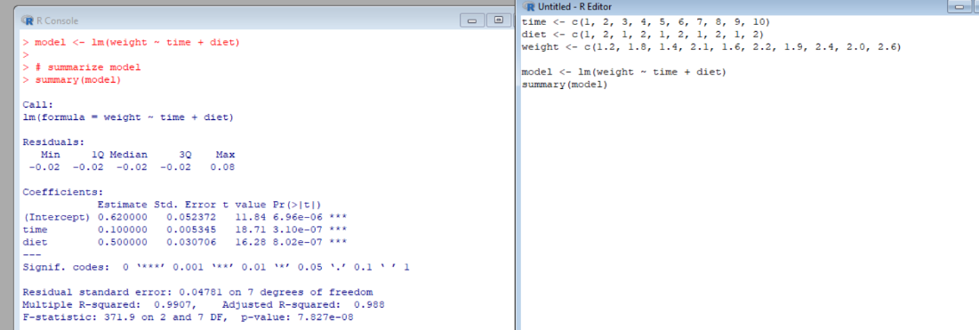

b)

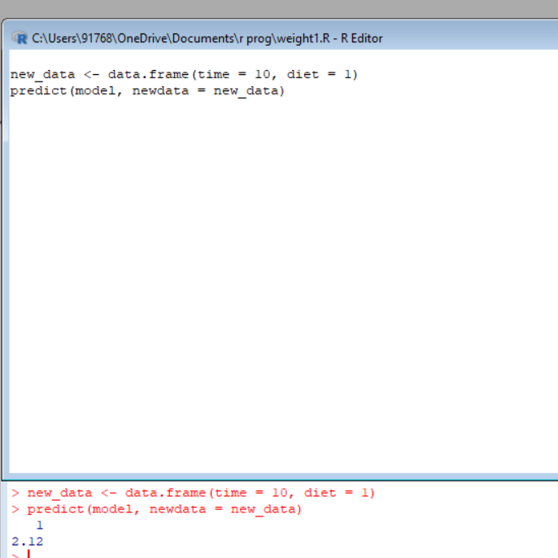

c)

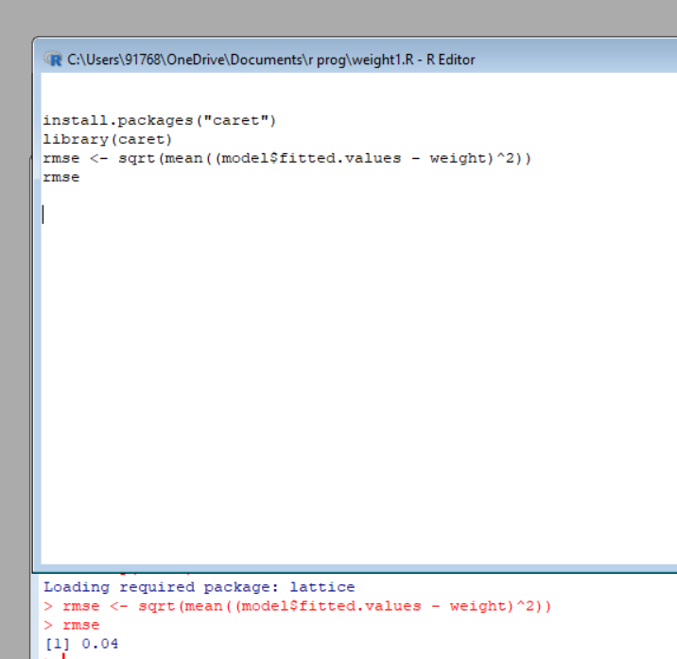

2 ..For this exercise, use the (built-in) dataset Titanic.

a. Draw a Bar chart to show details of “Survived” on the Titanic based on passenger

Class

b. Modify the above plot based on gender of people who survived

c. Draw histogram plot to show distribution of feature “Age”

SOURCE CODE:

A)

data(Titanic)

survived_by_class <- aggregate(Freq ~ Class, data = Titanic, FUN = sum)

barplot(survived_by_class$Freq, names.arg = survived_by_class$Class,

xlab = "Passenger Class", ylab = "Number of Survivors",

main = "Survivors on the Titanic by Passenger Class",

col = "steelblue")

B)

survived_by_class_gender <- aggregate(Freq ~ Class + Sex, data = Titanic, FUN = sum)

survived_by_class_gender_wide <- reshape(survived_by_class_gender,

idvar = "Class",

timevar = "Sex",

direction = "wide")

barplot(height = t(survived_by_class_gender_wide[, -1]),

beside = TRUE,

names.arg = survived_by_class_gender_wide$Class,

legend.text = colnames(survived_by_class_gender_wide)[-1],

xlab = "Passenger Class",

ylab = "Number of Survivors",

main = "Survivors on the Titanic by Passenger Class and Gender",

col = c("steelblue", "darkorange"))

C)

data(Titanic)

titanic_age <- Titanic[complete.cases(Titanic$Age), ]

hist(titanic_age$Age,

breaks = 20,

xlab = "Age",

ylab = "Frequency",

main = "Distribution of Age on the Titanic",

col = "steelblue",

border = "white")

OUTPUT:

A)

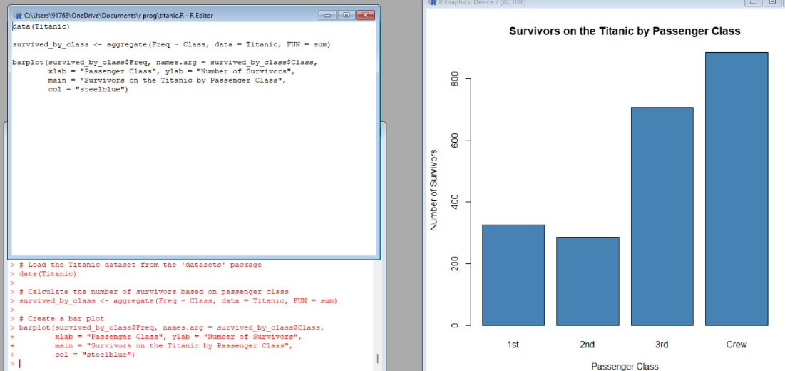

B)

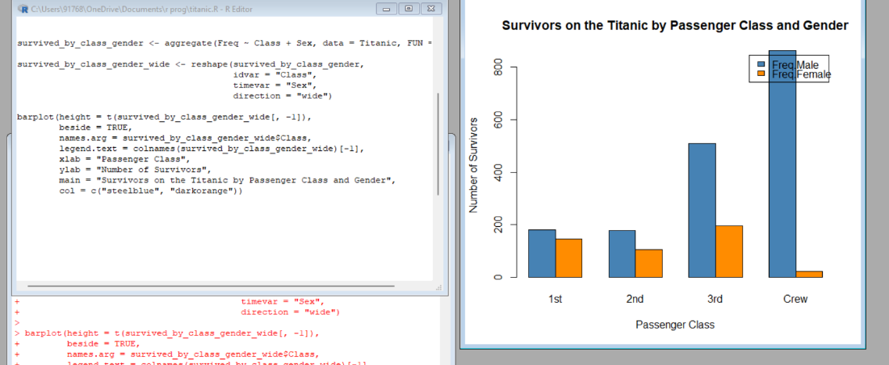

C)

**4. a. Create a data frame based on below table.**

**Source Code:**

# Create the Month and Spend vectors

Month <- c(1, 2, 3, 4, 5, 6, 7, 8, 9, 10, 11, 12)

Spend <- c(100, 0, 4000, 5000, 4500, 3000, 4000, 9000, 11000, 15000, 12000, 7000, NA)

# Create the Sales vector

Sales <- c(9914, 40487, 54324, 50044, 34719, 42551, 94871, 118914, 158484, 131348, 78504, 36284)

# Create the data frame

data <- data.frame(Month, Spend, Sales)

# Print the data frame

print(data)

**OUTPUT:**

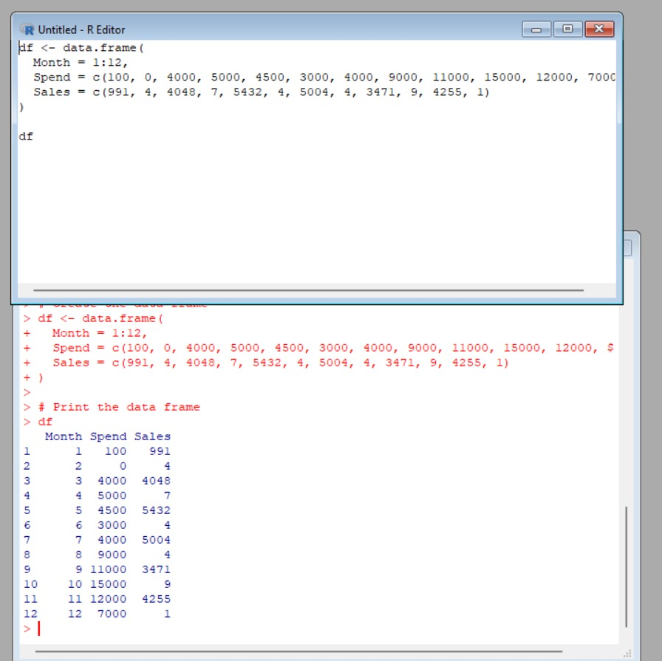

**5.(i) Write a R program to extract the five of the levels of factor created from a random**

**sample from the LETTERS (Part of the base R distribution.)**

**Source Code:**

# Create a random sample of LETTERS

random_sample <- sample(LETTERS, size = 10, replace = TRUE)

# Convert the sample to a factor

factor_sample <- factor(random_sample)

# Extract five levels from the factor

five_levels <- levels(factor_sample)[1:5]

# Print the five levels

print(five_levels)

**OUTPUT:**

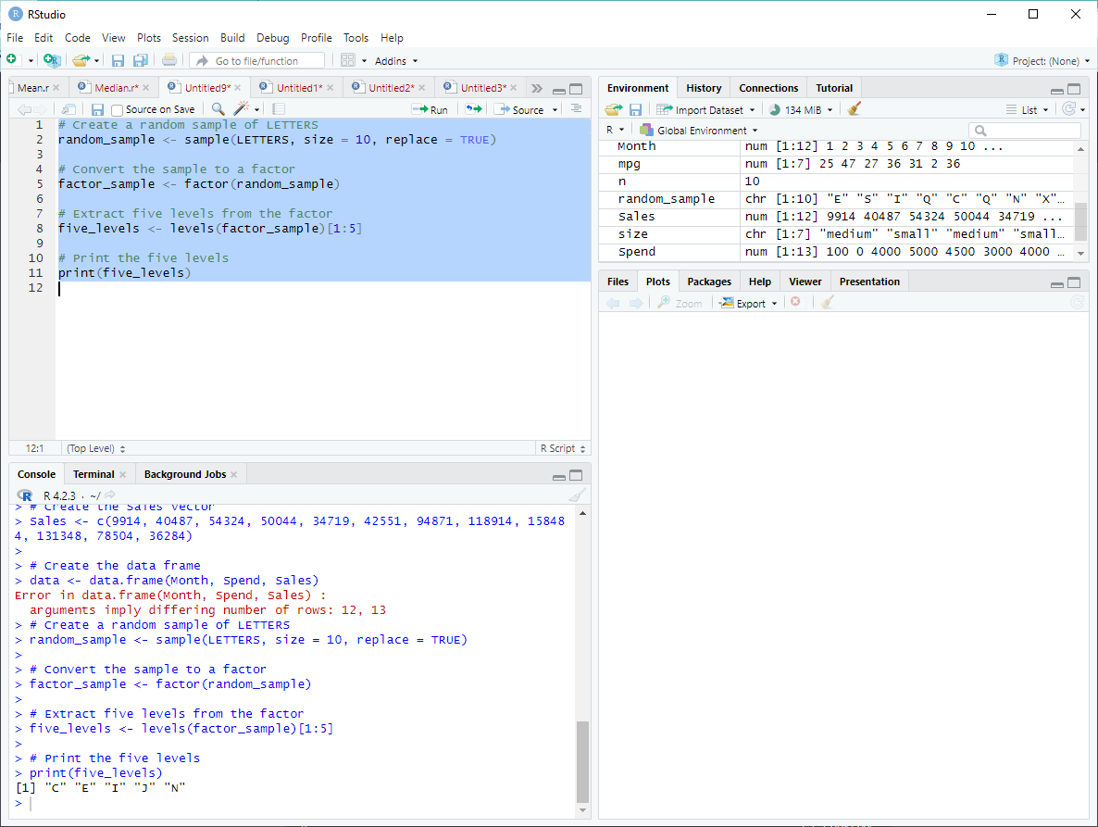

**(ii)Write R function to find the range of given vector. Range=Max-Min**

**Sample input, C&lt;-(9,8,7,6,5,4,3,2,1),**

**output=8**

**Source Code:**

# Define the vector

C <- c(9, 8, 7, 6, 5, 4, 3, 2, 1)

# Find the range

range_value <- max(C) - min(C)

# Print the range

print(range_value)

**OUTPUT:**

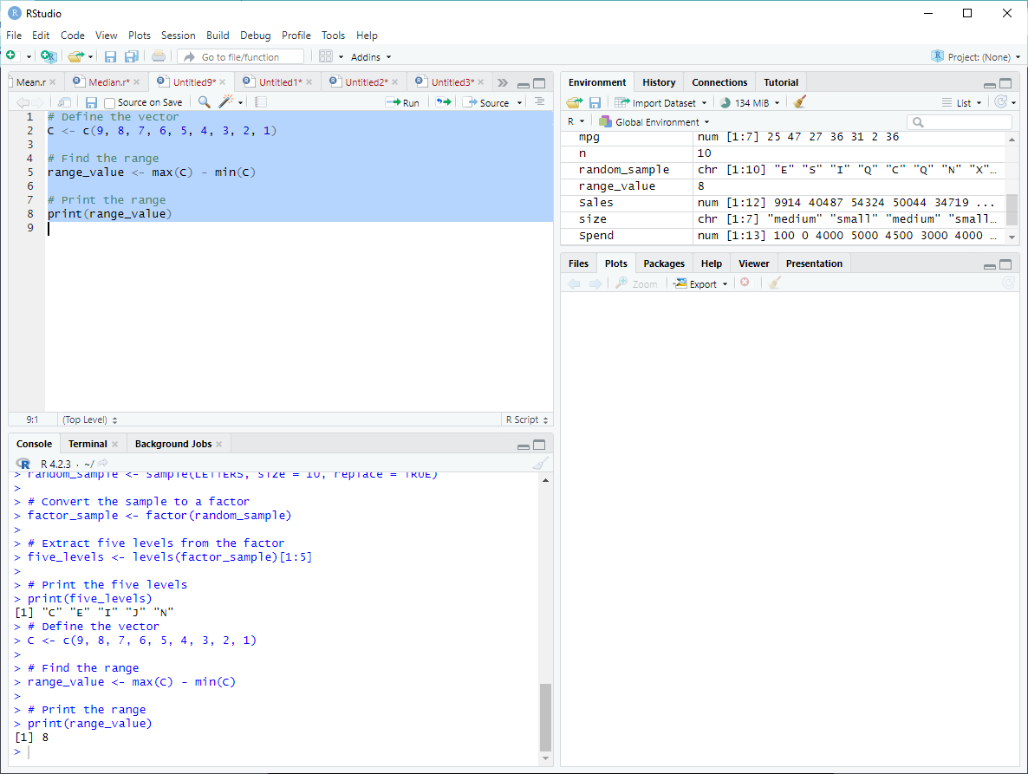

**(iii)Wirte the R function to find the number of vowels in given string**

**Sample input c&lt;- “matrix”,  output&lt;-2**

**Source Code:**

# Install and load the stringr package

install.packages("stringr")

library(stringr)

# Define the string

c <- "matrix"

# Find the number of vowels

num_vowels <- str_count(tolower(c), "[aeiou]")

# Print the number of vowels

print(num_vowels)

**OUTPUT:**

